**Activity #1**

**Future in the Past**

**PART 1**

**Instructions: Join each idea in A with an idea from B. Make sentences using WAS / WERE GOING TO**

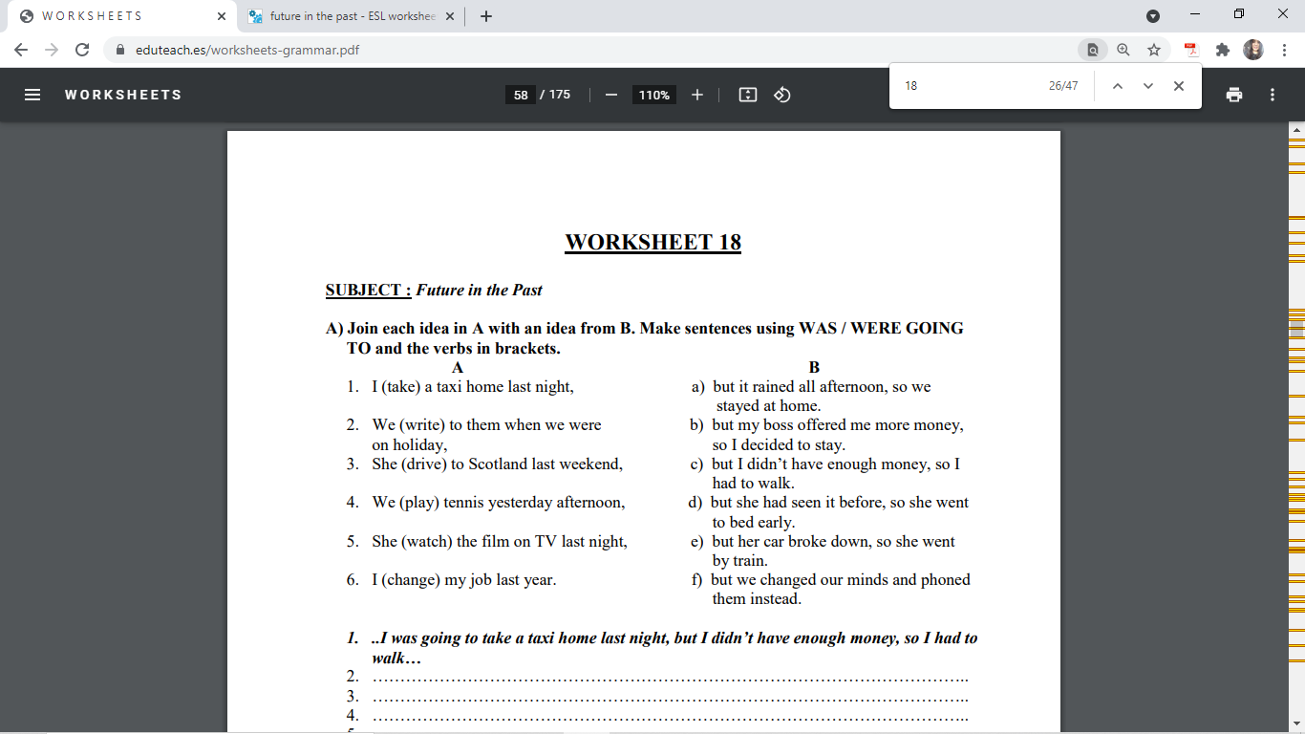

**1.** I was going to take a taxi home last night, but I didn’t have enough money, so I had to walk.

**2**. We were going to write them when we were on holiday, but we changed our minds and phoned them instead.

**3**. She was going to drive to Scotland last weekend, but her car broke down, so she went by train.

**4**. We were going to play tennis yesterday afternoon, but it rained all afternoon, so we stayed at home.

**5**. She was going to watch the film on TV last night, but she had seen it before, so she went to bed early.

**6.** I was going to change my job last year, but my boss offered me more money, so I decided to stay.

**PART 2**

**Instructions: Complete the exercise in the following link. Take a screenshot (with time and date), copy and paste it in this section**

[**https://es.liveworksheets.com/zf1400951fl**](https://es.liveworksheets.com/zf1400951fl)

